US Trading Bot:
1. Inconsistency with engine trade selection, selection A only setup for today’s trade but system traded B setup.
2. Adding stop trade feature for live trades for each position. 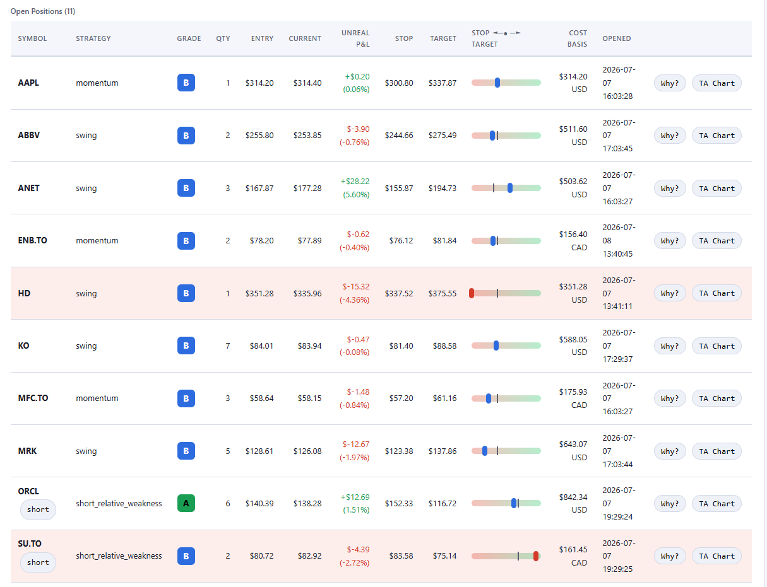

3. 401 error for the Analysts section 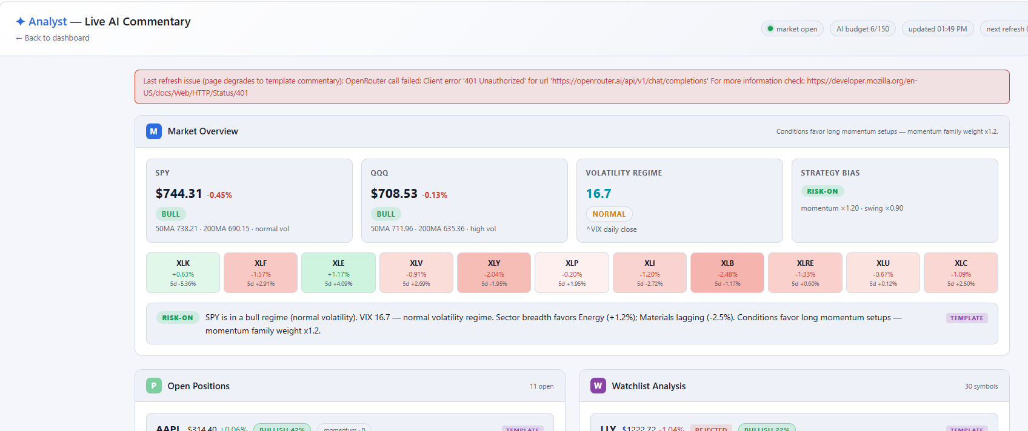

4. Short trading strategies are not part of the back-test and engine trade selection. We need to also include the short trade strategies everywhere where there are trading strategies selections.

